FULL NAME

ORGANIZATION/AFFILIATION |  | JOB TITLE/POSITION
PHONE | EMAIL ADDRESS
COURSE TYPE  MHFA Basic MHFA Youth  MHFA Seniors safeTALK  The Mentally Health Workplace | DATE(S) |  | LOCATION
COURSE FEE  $ | ADD HST (15%)  $ |  | TOTAL  $
SPECIAL REQUIREMENTS (e.g. mobility concerns, allergies, etc.)

How did you hear about this course?

Payment in full must be received to reserve your seat in any training session, in addition to this completed form.
If you are registering by mail, please ensure you also email mhfa@email.com to let us know to expect your documents. Cheques or money orders made payable to ARPEGGIO MUSIC THERAPY can be mailed to:
ATTN: Elizabeth Eldridge
Pay online at arpeggio.anchor87.com (Paypal, any major credit card or Visa Debit) or request an invoice by contacting us at 506.754.6298 or mhfa@email.com
19 Carleton Street
St. George, NB
E5C 3B6
Send e-transfers to mhfa@email.com; please send a separate email with the answer to the security question.
In the event that the minimum required number of participants is not reached, you will be notified via email that the session has been cancelled at least one week prior to the intended course start date, at which time you may choose to receive a refund or to apply the registration fee to a future course.
Cancellation Policy:
Notice given 10+ days prior to course – Full refund Notice given 7- 9 days prior to course – 50% refund
Notice given less than 7 days prior to course start date/no advance notice given – NO REFUND
By submitting this registration form, I am indicating my acknowledgement and agreement to the Cancellation Policy outlined above and understand that no exceptions to the policy will be made for any reason.
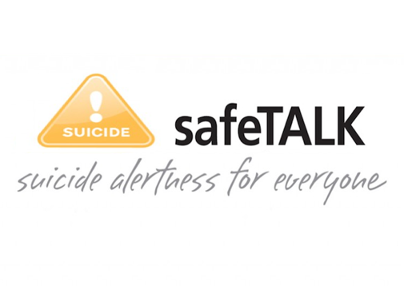
Registration Form

